ECE 403

Senior design II

Options Considered Document

February 13, 2015

Andrew Bossert

Christopher Jorden-Denny

Nicolette Lippert

**Introduction**

This project is looking for an answer to the question is the transmembrane potential of cells effected by exposure to radio frequencies. The question steams off of previous research conducted by Dr. Ewert, and those at NDSU, and is a part of a collection that is researching an electrical engineering approach to effect the functions of cells and the shape of cell proteins. Advances in this area have many real world application ranging from curing many diseases to a wirelesses pace-maker device.

## **Previous Work**

Dielectric Properties of Yeast Cells Expressed with Motor Protein Prestin:

It is shown that the low-frequency dielectric response of biological systems is enormous, but decreases rapidly with increasing frequency (Miller Jr., et al. 2005). This response can be seen in Figure 4.

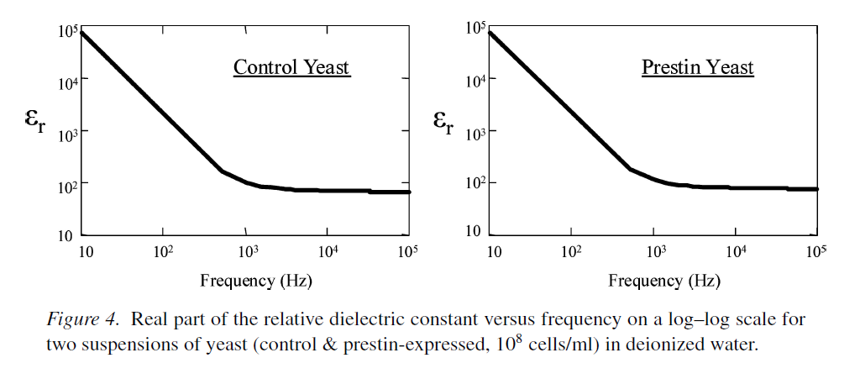

The use of radio frequencies to alter biological systems seems unlikely after seeing the results above, however you will notice that measurements stopped at a frequency of 105 Hz. Our experiment will be looking at frequencies in the range of 1GHz to 8.5GHz which has not been tested.

The method that was used in (Miller Jr., et al. 2005) to receive that data above was using dielectric probes to measure cells in suspension. A general circuit diagram can be seen in Figure 2.

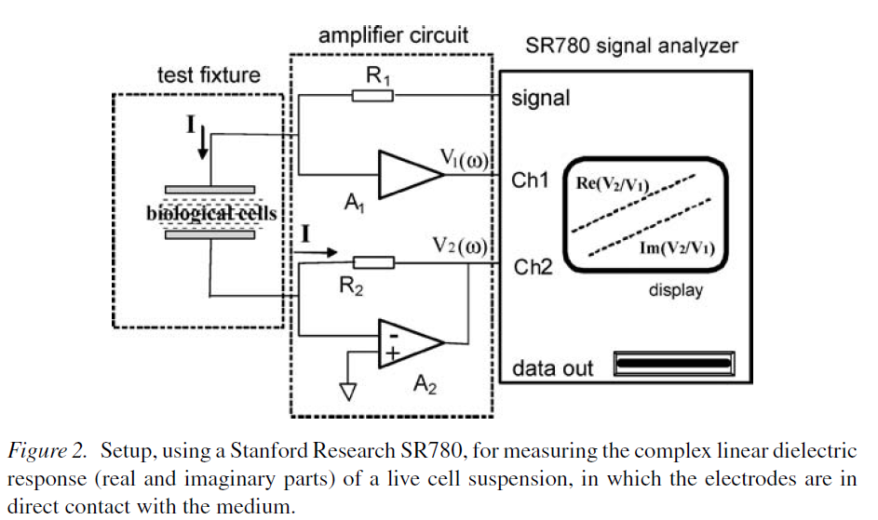

### Linear Response:

In the case above the biological cells are suspended in 108 cell/ml of deionized water. The reference voltage wave form is applied through R1 to the upper electrode. The SR780 uses a frequency sweep as the signal output and Ch1 and Ch2 are digitized inputs in the time domain, which the SR780 then takes the fast Fourier transform to determine the relative magnitudes and phases of the input voltages $V_{1}(ω)$ and $V_{2}(ω)$ in the frequency domain and also computes the complex ratio of these two amplitudes $\frac{V_{2}}{V_{1}}$. The bottom electrode is connected to the negative input of amplifier A2 which holds the electrode at ground potential.

$$V_{1}=I\left(conduction and displacement\right)∙Z_{cellsuspension}$$

$$V_{2}=I∙R_{2}$$

$$\frac{V_{2}}{V_{1}}=\frac{R_{2}}{Z}$$

The purpose of $R_{1}$ is to provide an upper limit on the current $I$ as the impedance Z becomes small at high frequencies, while the unity gain amplifier $A_{1}$ acts as a buffer.

### Nonlinear Response:

A four probe-electrode suspended in the cell suspension is used to measure nonlinear responses of the system. This diagram can be seen in Figure 3.

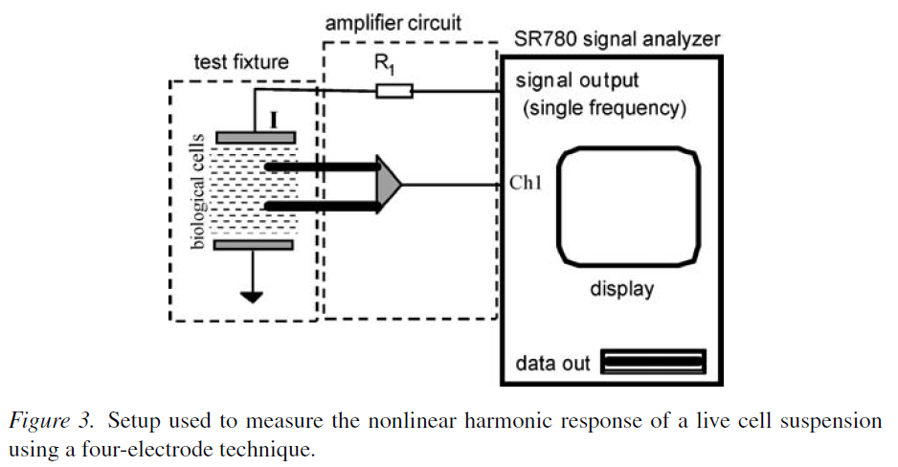

A sinusoidal voltage is applied to the outer electrodes and the cell response across the inner pair of electrodes is measured as a function of frequency. The nonlinear dielectric response can be seen in Figure 6.

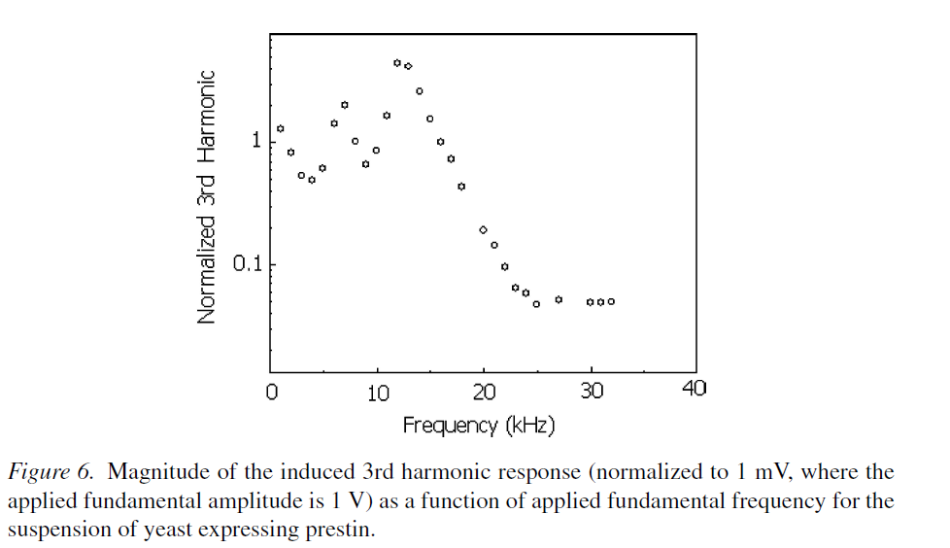

### Dielectric Spectroscopy for bioanalysis: From 40 Hz to 26.5 GHz in a microfabricated wave guide:

A report on developing coplanar waveguide devices which can perform dielectric spectroscopy on biological samples within a microfluidic channel. These devices yield permittivity spectra across an exceptionally broad range of frequencies: from 40 Hz to 26.5 GHz thus far. Neither chemical treatment nor surface activation is required. This device can be seen in Figure 1. (Facer, Notterman and Sohn 2001)

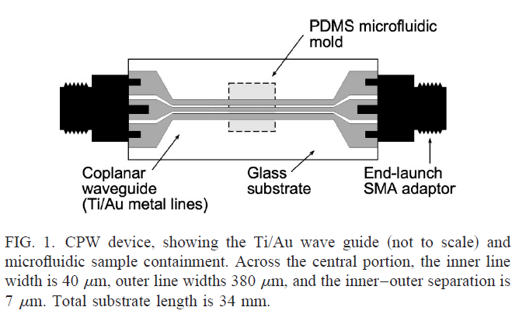

At frequencies below ~100 MHz, the relative permittivity is obtained from the impedance Z.

C0 is the capacitance through the sample volume when empty, typically 10fF

$$ϵ=ϵ_{HF}+\frac{ϵ_{LF}-ϵ_{HF}}{1+{\left(jωτ\right)}^{α}}-j\left(\frac{σ_{LF}}{ω}\right)$$

$ϵ_{LF}-ϵ_{HF}$“is the dielectric increment,” $τ$ is a characteristic time constant, $α≤1$ defines the sharpness of the transition, and $σ_{LF}$ is the dc conductivity.

# References

Facer, G. R., D. A. Notterman, and L. L. Sohn. 2001. "Dielectric spectroscopy for bioanalysis: From 40 Hz to 26.5 GHz in a microfabricated wave guide." *Applied Physics Letters* 996-998.

Miller Jr., John H, Dharmakeerthi Nawarathna, David Warmflash, Fred A Pereira, and William Brownell. 2005. "Dielectric Properties of Yeast Cells Expressed With the Motor Protein Prestin." *Journal of Biological Physics 31* 465-475.

Nawarathna, D., J. H. Miller Jr., J. R. claycomb, G. Cardenas, and D. Warmflash. 2005. "Harmonic Response of cellular Membrane Pumps to Low Frequency Electric Fields." *Physical Review Letters* 158103-1 - 158103-4.

Prodan, C., F. Mayo, J. R. Claycomb, J. H. Miller Jr., and M. J. Benedik. 2004. "Low-frequency, low-field dielectric spectroscopy of living cell suspensions." *Journal of Applied physics* 3754-3756.

**Design Options and selected Approach**

Overview

Our overall project objective is to determine the effect, if any, radio frequencies have on the transmembrane potential of cells. The project has a heavy dependence on research and would be considered a research project. As well, the field in question is relatively unexplored. Considering these things gives a large amount of freedom in the path to take to accomplish the goal. Very little restrains have been placed on the project by the client.

The first task is to design or modify a device or technique to measure transmembrane potential. Through research and sources provided by Dr. Ewert a few plausible techniques can be found.

CPW Device (Coplaner Waveguide):

A device reported in the journal “Applied Physics Letters” claimed to be capable of dielectric spectroscopy on biological samples within a microfluidic channel at frequencies of 40Hz to 26.5GHz with no surface functionalization or chemical sample preparation required.

Advantages

* Tested within our frequency requirements and shown to work.
* No surface functionalization or chemical sample preparation required
* Sensitive technique that can probe a system at various length scales from centimeters to microns, with sample volumes as small as picoliters.

Disadvantages

* Complex manufacturing required and use of complex machines.

Superconducting Quantum Interference Device:

Several groups that we have researched have implemented these superconducting quantum Interference devices (SQUIDS) in order to improve their measurements and reduce electrode polarization. SQUIDS are very sensitive pieces of equipment that can detect very subtle magnetic fields.

Advantages

* extremely accurate measurements

Disadvantages

* intensive and complex design
* expensive

Conductive Probes:

One method that was introduced is inserting a glass probe filled with a conductive fluid into the cell and then having another probe outside of the cell. If you attach the probes to a volt meter or a circuit that can determine the potential difference you will have the measurement you are looking for.

Advantages

* Proven Method of measurement
* Fairly simple and straight forward to implement

Disadvantages

* The conductive glass probes will act like an antenna in the presence of radio waves. This would skew the measurement and make it unclear as to what is causing the potential reading form the meter.

Measure Cells in a Suspension:

Through research a method of measuring cell potential using a cell suspension. This method involved applying a current to two plates submersed in a cell suspension. The output current was then run through an amplifier circuit and the data transmitted to a Stanford Research SR780 for measuring and storing the data.

Advantages

* Measurement device may be unaffected by radio waves
* Requires only a cellular suspension to measure the transmembrane potential

Disadvantages

* Design is slightly more complicated compared to the Conductive Probes option
* The method and technology used is somewhat outdated

Linear and Nonlinear Components:

In researching this experiment we have come across data that suggest the output response from measuring a cell's transmembrane potential has both linear and nonlinear components. This will be something to consider when designing an experiment and a device to measure the transmembrane potential. The output could have various different harmonics and we will need to decide which ones carry importance based on the question we are asking.

Experiment Design

Once a technique for measuring transmembrane potential is realized an experiment will need to be devised in order to answer the original question. There are a few different parameters to look at when it comes to experiment design.

What kind of cells do we measure:

Looking at other's research and simply by having a little background in biology you will find that there are more than one type of cell. There are prokaryotic and eukaryotic cells, there are heart cells and mitochondrial cells, and there are neurons that display interesting transmembrane potential characteristics. All of these different types of cells have been seen being measured by other groups and choosing one will impact how the experiment is carried out.

How many measurements do we take:

If we take a look at the experiment from a statistical analysis point of view one measurement is statistically irrelevant. We will need to repeat our experiment multiple times. We will need to review data analysis methods and choose a fitting one for us. Then we will need to analysis the method we choose and arrive at a number of experiments that will allow us to give meaningful results

Where do we take measurements:

The location of the experiment is an important thing to consider. There are radio waves almost everywhere, which can affect the measurement of a control. One possible solution to this would be to conduct the experiment in a shielded room. Another possible method would be to compensate for the constant presences of radio waves using a filter device or some sort of mathematical manipulation. Other things to consider for the location are the basic elemental factors such as temperature, humidity, maybe even barometric pressure.

Selected Approach

As the project is very unclear as to what the outcome will be, the approach we have chosen can be described as a two pronged attack. The Superconducting Quantum Interference Devices were never really an option to begin with. They are very highly sophisticated pieces of machinery and are out of the scope of this experiment for the time we have. However both the convention way of measuring transmembrane potential with conductive glass pipettes and the method of measure transmembrane potential in a cell suspension that we saw in a research document show promise. At this point in time we do not know enough about our end goal or either of the methods to rule them out. They are both fairly straight forward concepts we will need to flesh out a more specific design as time progresses.

Both methods are broad ideas at how to accomplish a goal at this point. This means more research and experts consulted will be required in order to nail down the exact details and advantages and disadvantages to each design. These methods will be broken up into individual projects which has the potential for individual leadership within the group. There is the possibility that one method is found implausible in which case focus will be directed toward the other method. At the end of the current semester if both methods are presented as valid approaches then the methods will be revaluated and a main experimental method will be chosen. This would be a best case scenario because it would keep experiment option wide open and if time permits both ideas could be implemented providing even more data to answer the overall question at hand.

Block Diagram



Research the Method

Both method have been presented to us by the project facilitator and we have seen documentation on both methods. The task at this stage is to exhaust all research outlets to make design easy. This will hopefully turn up things such as circuit diagrams, advantages and disadvantages, problems others encountered. All of this data will be used to design a method of measurement that will suit out needs. For the glass pipettes the question of will they act as antenna or not could be address here and a method of overcome this problem could be thought up at this stage. Also at this stage talking with other experts on bioengineering in the department and even those in the biology department at NDSU would be helpful. At this stage there is room for each idea to evolve and change a little to allow the possibility for it to be designed and to allow it to meet our needs.

Design

Once adequate information has been collected a device or technique will need to be created. This can be done using circuit schematics that have been collected using devices that were recommended to the student by consulted experts or however the best method was discovered. This stage has the potential for some circuitry to be created, meaning things like PCB's, bread boarded circuits, and other engineering design ideas will be considered here.

Test

At this state in the process we are looking to answer the question how do we measure transmembrane potential. Once we have a device we will try and use it. If it doesn't measure the potential we can't use it and it will either be eliminated or redesigned. The testing procedure could look like a real experiment, but will be less formal and simply prove to the group that the idea does or does not work.

Document

In order to choose a method of measurement accurate records and data must be keep and should not only be formalized at the end of the test, but should be keep throughout. This will allow the group to look back and see why certain decisions were made and will help streamline the process. A semi formal report will be used in order to reconsider and re-plan the design for the formal experiment. A summary of what we know and have learned will be critical for future decision making.

Future Planning

Once the group is at the stage where the options of preceding can be reconsidered more planning and more detailed planning will take place. This is dependent on the results of the first stage of the design process and therefore the exact details cannot be laid out here. However, a sensible stagey of preceding can be seen because an experiment will need to be implemented and one question implementing the

experiment will ask is how do we measure transmembrane potential.

**Budget**

|  |  |  |  |  |
| --- | --- | --- | --- | --- |
| ***Part*** | **Part Number** | **Price($)** | **Quantity** | **Total($)** |
| *PCB* | -- | 50 | 2 | 100 |
| *Microprocessor* | ATMEGA8U2-AU-ND | 4.38 | 2 | 8.76 |
| *RS-232 Port* | 609-2801-ND | 2.79 | 2 | 5.58 |
| *Op-Amp* | LT1115CSW-ND | 7.04 | 2 | 14.08 |
| *Crystal* | X439-ND | 0.81 | 2 | 1.62 |
| *DAC(CDC)* | Ad7147acpz-1500rl7ct-nd | 3.5 | 2 | 7 |
| *Voltage converter* | 497-7255-1-ND | 0.66 | 2 | 1.32 |
| *Cells* | -- | 150 | -- | 150 |
| *Capacitors/Resistors* | -- | 10 | -- | 10 |
| *AVR Programmer* | -- | 50 | 1 | 50 |
| *Miscellaneous Connectors* |  | 10 |  | 10 |
| *Probes/Biological Equipment* | -- | 150 |  | 150 |
| *Total Cost* | -- | 0 | -- | 508.36 |

**Summary**

The objective of this project is to answer the question: is the transmembrane voltage potential of cells affected by radiofrequency of the electromagnetic spectrum. We will try to implement the two different design detailed in this report in order to determine which one is the best method for out experiment. The two methods are using the glass pipettes, and the cell suspension. Each has their own pros and cons and this is what we will be exploring in our research and experimentation. The funds we request for this project are $346.36.